PROBLEM LINK : http://www.spoj.com/problems/TRENDGCD/

EDITORIALIST : Adarsh kumar

DIFFICULTY : Medium

PREREQUISITES : Mobius Inversion , Fast summation.

PROBLEM :

Given A and B you need to calculate S(A,B).
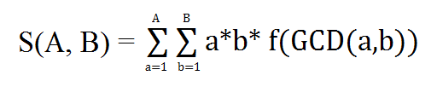
Here, f(n)=n, if n is square free otherwise 0. Also f(1)=1

QUICK EXPLANATION :

Eliminate the gcd part by writing it in the form of its sum function using mobius inversion !
Rearrange to get the computable expression.

EXPLANATION :

Assume throughout that A<=B.

Mobius Inversion Theorem :

If g and f are arithmetic functions satisfying

Then

Here is mobius function.

So using this above expression reduces to

=
=
=

Now problem reduces to finding g(d) function
Using inversion formula

If n is divisible by for some p,then g(n)=0.
So n can take form of for g(n) to be non-zero.
Let k= and m=
So
Substituting value of n

Now Main task left is to find g(n).
We can precompute g for each n<=1000000 by calculating a prime factor of p using segmented sieve.If p divides n then else if divides n then else g(n)=0.

To compute as |A/d| can take atvalues and |B/d| can take at most values, so we can precompute for all k<=1000000 and can group terms which can take same values for |A/d| and |B/d|.

Take all answers mod

COMPLEXITY : O( N + T * N^{1/2})

